Project Design Phase-II
Data Flow Diagram & User Stories

Date | 19/02/2026
Team ID | LTVIP2026TMIDS39395
Project Name | ShopSmart – Digital Grocery Web Application
Maximum Marks | 4 Marks

Data Flow Diagrams:
A Data Flow Diagram (DFD) is a traditional visual representation of the information flows within a system. A neat and clear DFD can depict the right amount of the system requirement graphically. It shows how data enters and leaves the system, what changes the information, and where data is stored.

Example: (Simplified)


Technical Architecture:
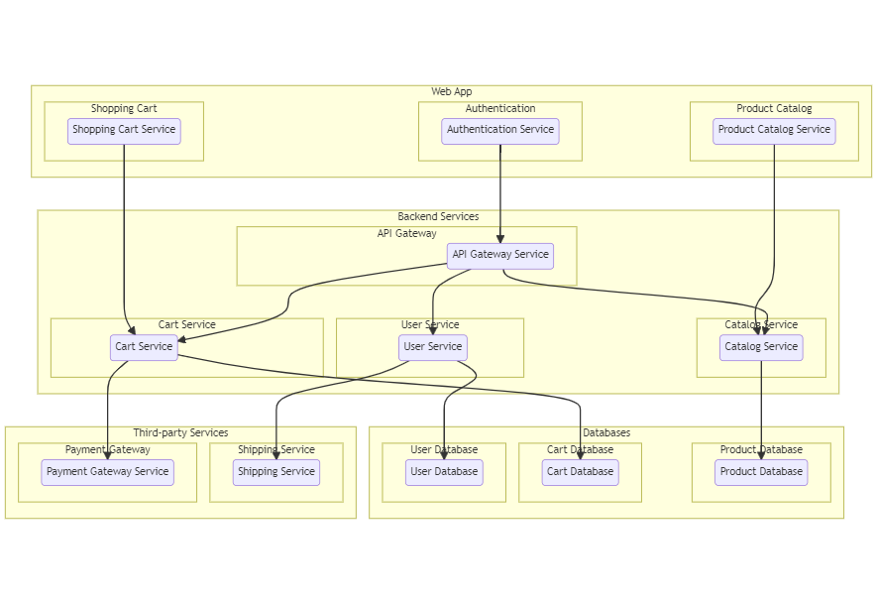

User Stories
Use the below template to list all the user stories for the product.
User Type | Functional Requirement (Epic) | User Story Number | User Story / Task | Acceptance criteria | Priority | Release
Customer (Mobile user) | Registration | USN-1 | As a user, I can register for the application by entering my email, password, and confirming my password. | I can access my account / dashboard | High | Sprint-1
 |  | USN-2 | As a user, I will receive confirmation email once I have registered for the application | I can receive confirmation email & click confirm | High | Sprint-1
 |  | USN-3 | As a user, I can register for the application through Facebook | I can register & access the dashboard with Facebook Login | Low | Sprint-2
 |  | USN-4 | As a user, I can register for the application through Gmail |  | Medium | Sprint-1
 | Login | USN-5 | As a user, I can log into the application by entering email & password |  | High | Sprint-1
 | Product Search | USN-6 | As a user, I can search products by name/category | Relevant products displayed | High
  Sprint-1
Customer (Web user) |  |  |  |  |  | Sprint-1
  Add to Cart
  USN-7
  As a user, I can add items to cart
  Items visible in cart
  High
 | View Orders |  | As a user, I can view order history | Order list displayed | Medium | Sprint-2
  USN-8
Customer Care Executive | Customer Care Executive |  | As a customer care executive, I can view customer complaints and queries | All customer queries are displayed |  | Sprint-1
  USN-9
  high
 | Respond to Queries |  | As a customer care executive, I can respond to customer issues | Response sent successfully to customer |  | Sprint-1
  USN10
  High
Administrator |  |  |  | Product list updated | High | Sprint-1
  Manage Products
  USN11
  As an admin, I can add/edit/delete products
 | Manage Orders |  | As an admin, I can view & update order status | Order status updated | High | Sprint-1
  USN12

